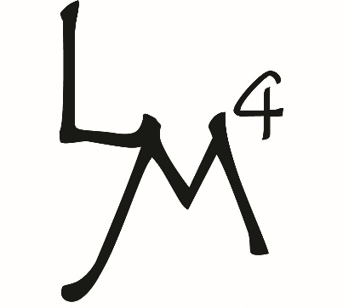
FLU ENGERIX TUBERSOL
COVID-19 HAVRIX MMR
SHINGRIX TYPHIM VARIVAX
ADACEL ABRYSVO MENQUADFI
PREVNAR 20 CAPVAXIVE
Bill to:
Do you have Medicare Advantage plan? YES NO
Retired Teacher? Please use UHC card for flu/covid/pneumonia! YES NO
Enrolled in Hospice? YES NO

Consent and Release Injectable Vaccinations
Louis Morgan #4 - Pharmacy, Gifts & More - 110 Johnston Street - Longview, Texas 75601 - 903-758-6164 - WWW.LMD4.COM
 | Medicare#_________________________ |  | DOB:____________________ |  |  | Age___________________ |  |  |  | Male/Female
 | Last Name:______________________ | First Name:______________________ |  |  |  |  | Middle:_________________________
 | Address:________________________________________ |  |  |  | City:__________________ |  |  |  | State:________ Zip:_________
 | Phone Number:______________________________ |  |  | Primary Care Physician:_________________________________
 | I acknowledge that I understand the benefits and risks of the requested vaccination as described in the Vaccine Information Sheet, a copy of which is provided with this Consent and Release. I confirm that Louis Morgan Drugs #4 has answered to my satisfaction all my questions about the vaccine, and the vaccination procedure. I request and consent the vaccination to be given, as I directed Louis Morgan Drugs #4. Either to me or to the person named above, a minor for whom I represent that I am authorized to sign this Consent and Release. I understand that I am giving Louis Morgan Drugs #4 permission to release any medical or other information necessary to my physician, Medicare, Medicare HMO, or insurance company or immunization registry, as applicable, to enable Louis Morgan Drugs #4 to process my insurance claims with respect to the vaccination. I, for myself (and for the recipient of the vaccination, if the recipient is a minor), my heirs, executors, and assigns herby release Louis Morgan Drugs #4 from any and all claims arising out of or in connection with the quality of the below described vaccine(s) as provided by the manufacturer and any negligence of Louis Morgan Drugs #4 in connection with the related injection of the vaccination. I understand that the laws of my state may affect my remedies in connection with this vaccination. I understand that if my insurance does not pay for this vaccine, I will be personal responsible for any amount due to Louis Morgan Drugs #4.
Please answer questions by checking the boxes.  If the question is not clear, please ask the pharmacist. |  |  |  |  |  |  |  | Yes |  |  | No
Have you ever received a SHINGLES vaccine?
Are you sick today?
Do you have a serious allergy to ANY medications or food?
(Example: Eggs, Gelatin, Thimerosal, Neomycin, Gentamicin, etc.)
If yes, please list here:
_____________________________________________________________

Have you ever had a serious reaction or fainted after receiving any vaccination?
Do you have sensitivity to latex? (Example: Gloves, Bandages, etc.)
Women: Are you pregnant or are you considering becoming pregnant?
Have you received any vaccination in the past 4 weeks? Which one(s)?
_____________________________________________________________

Do you have cancer, leukemia, HIV, shingles, or any other immune system problem?
Do you take prednisone, oral steroids, anticancer drugs, antiviral medications or medications that affect the immune system?
During the past year, have you received a transfusion of blood or blood products, been given a medicine called immune (gamma) globulin or had radiation therapy?

X________________________________________________ _________________________
Signature of Person to Receive Vaccine(s) / Parent or Guardian of minor Date
Vaccine (circle given) | Manufacturer | Lot # | Exp. Date | Dosage/ ROA | Site of Injection | Time
Flu |  |  |  | 0.5 ml / IM | L / R Arm | AM / PM
Prevnar 20 | Pfizer |  |  | 0.5 ml / IM | L / R Arm | AM / PM
Shingrix | Glaxo |  |  | 0.5 ml / IM | L / R Arm | AM / PM
Adacel | Sanofi |  |  | 0.5 ml / IM | L / R Arm | AM / PM
SpikeVax | Moderna |  |  | 0.5 ml / IM | L / R Arm | AM / PM
 |  |  |  |  | L / R Arm | AM / PM
 |  |  |  |  | L / R Arm | AM / PM

X________________________________________________ _________________________
Signature of Pharmacist / CPhT / Intern Date

